Round – 1

L-1:

#include<stdio.h>

#include<conio.h>

#define square(x) x*x

#define cube(x) square(x)*x

Void main()  
{

int c;

c=cube(2+3);

printf(“%d”,c);

getch();

}

|  |  |
| --- | --- |
| a.) | 25 |
| b.) | 17 |
| c.) | 125 |
| d.) | None of these |

L-2: Add missing statement:-

#include<stdio.h>

#include<conio.h>  
void main()

{

int *j;

void fun(int **);

fun(&j);

}

void fun(int **k)

{  
int a=0;

______________________________//add a statement here.

}

|  |  |
| --- | --- |
| a.) | K=a; |
| b.) | K=&a; |
| c.) | *k=&a |
| d.) | **k=&a |

L-3:

#include<stdio.h>

#include<conio.h>  
void main()

{

char p[]=’%d\n’;

p[1]=’c’;

printf(p,65);

getch();

}

|  |  |
| --- | --- |
| a.) | K=a; |
| b.) | K=&a; |
| c.) | *k=&a |
| d.) | **k=&a |

Round - 2

L-4:

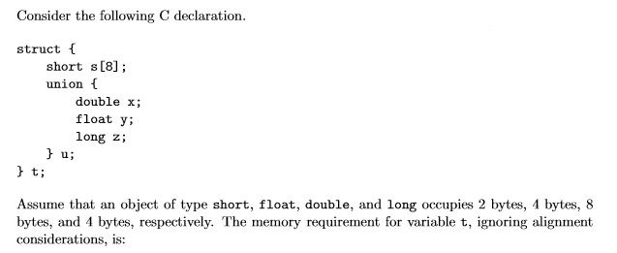

|  |  |
| --- | --- |
| a.) | 22 Bytes |
| b.) | 24 Bytes |
| c.) | 18 Bytes |
| d.) | 10 Bytes |

L-5:

#include<stdio.h>

#include<conio.h>

void main()

{

char s[]={‘a’,’b’,’c’,’\n’,’c’,’\0’};

char *p,*str,*str1;

p=&s[3];

str=p;

str1=s;

printf(“%d”,++*p + ++*str1-32);

getch();

}

|  |  |
| --- | --- |
| a.) | 164 |
| b.) | 77 |
| c.) | Garbage value |
| d.) | Compiler error |

L-6:

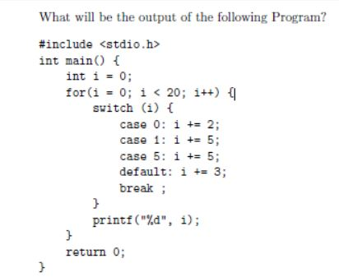

|  |  |
| --- | --- |
| a.) | 2 7 12 15 16 17 18 19 20 |
| b.) | 2 5 10 13 16 19 |
| c.) | 5 19 |
| d.) | Compiler error |

L-7:

WAP to print a substring of following string between indexes :- [3 to 8]

“C Programming” .

Round - 3

L-8:

#include<stdio.h>

#include<conio.h>

void main()  
{  
 int c[]={2.8,3.4,4,6.7,5};

int j,*p=c,*q=c;

for(j=0;j<5;j++)  
 {  
 printf(“%d”,*c);

++q;

}

for(j=0;j<5;j++)

{  
 printf(“%d”,*p);

++p;

}

getch();

}

|  |  |
| --- | --- |
| a.) | 2 2 2 2 2 2 3 4 6 5 |
| b.) | 3 3 3 3 3 3 4 5 6 |
| c.) | Compiler error |
| d.) | Run time error |

L-9: More than one choice may correct in following program:

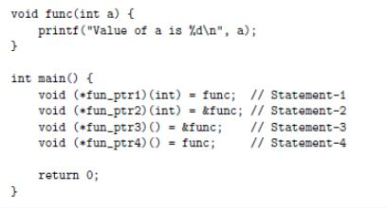

|  |  |
| --- | --- |
| a.) | Statement – 1 |
| b.) | Statement – 2 |
| c.) | Statement – 3 |
| d.) | Statement – 4 |

L-10 :  
WAP to Print :--

